Milan High School Library October 2015
Carla Freeman, Librarian Natasha Young, Library Assistant

Library Adds New “Thinker’s Corner” Section
Thanks to a new set of shelves courtesy of Cindy Tatum and Andy Tatum’s student painters, the library was able to add a new section aimed at advertising non-fiction books to readers. The new section is being dubbed “Thinker’s Corner” because it highlights books on religion, the military, forensics, sports, literature, conspiracy theories, mental health issues, and other informational texts that students may overlook when looking for something to read. Only a few weeks after adding the shelves, it appears to be a success as students are finding and checking out the newly featured books. Stop by the library and see the new section for yourself! Thanks to Mr. and Mrs. Tatum for their continued support of the library!
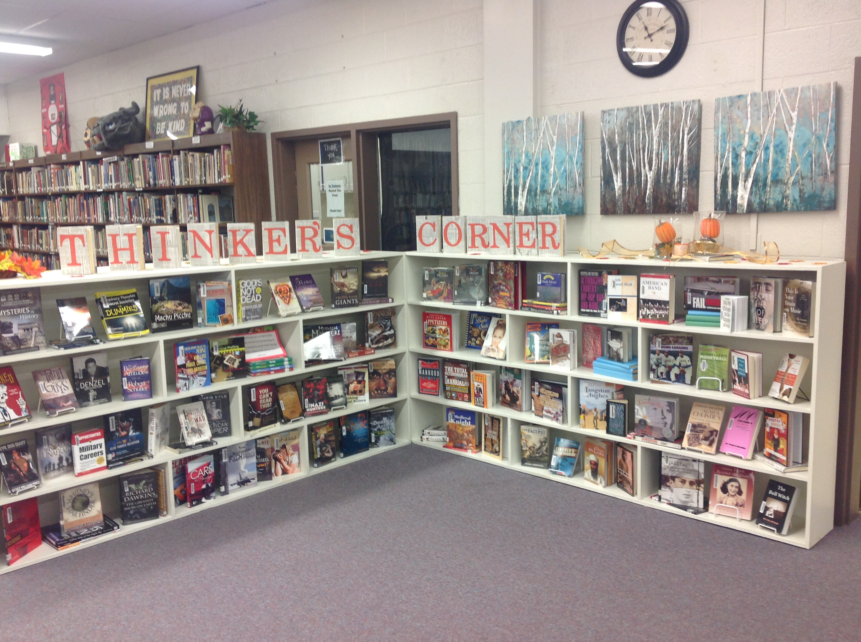

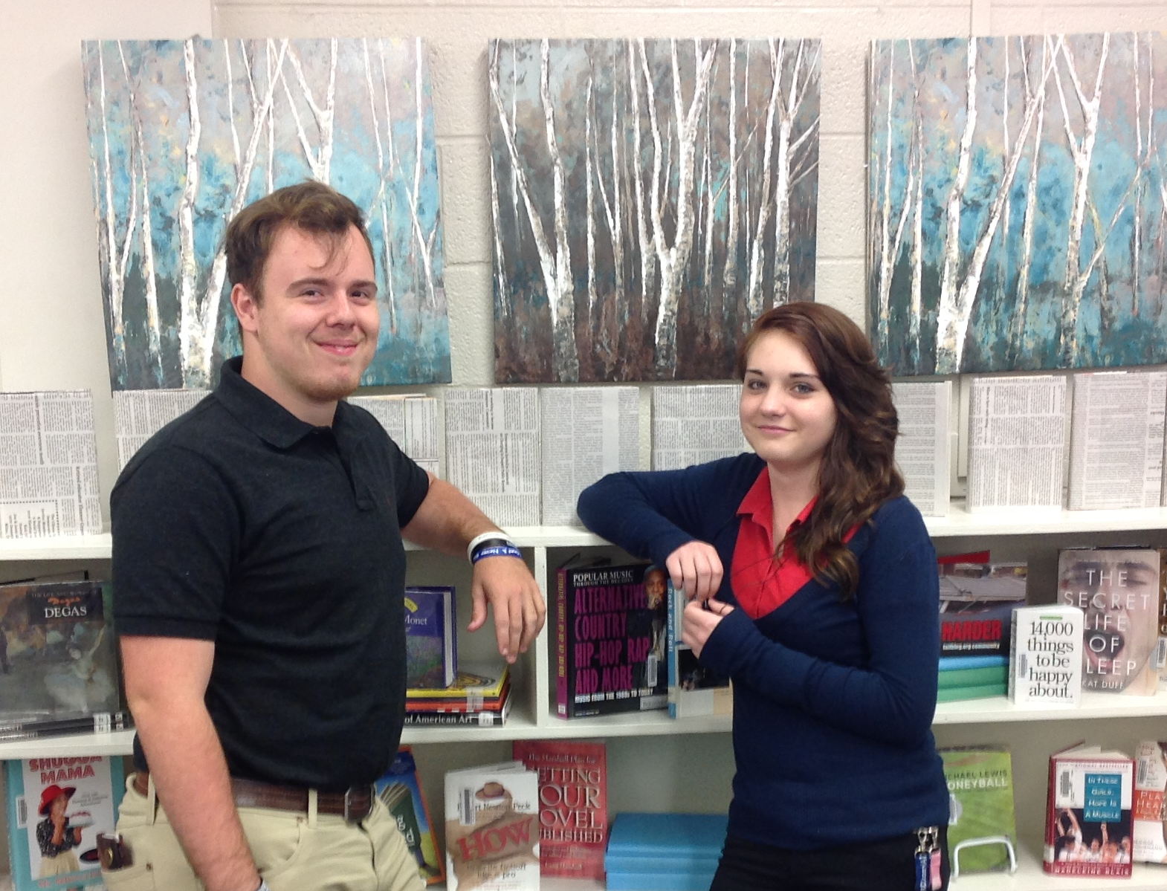
Above: New “Thinker’s Corner” Section
Right: Students Micah Powers & Breanna Britton donated time and painted shelves over a weekend

Student Visits in the Library

1767
Total student visits in the library during the month of September
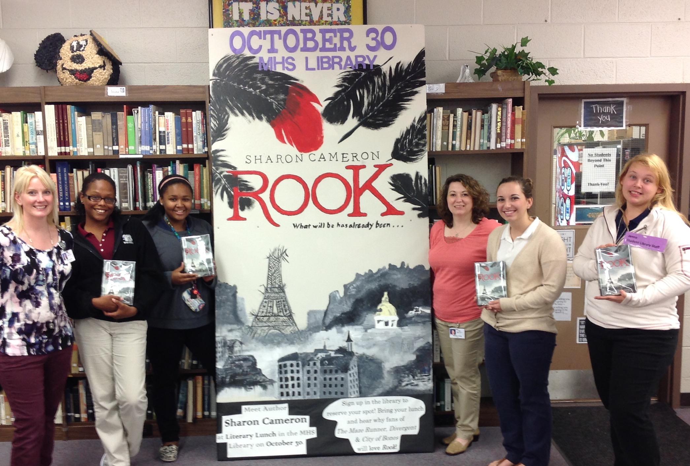

Circulation Statistics

618
Total books and other materials checked out of the library during September

Join us for Literary Lunch on Friday, October 30th with guest author, Sharon Cameron. Sharon Cameron was awarded the 2009 Sue Alexander Most Promising New Work Award and the 2013 Crystal Kite Member's Choice Award by the Society of Children's Book Writers and Illustrators for her debut novel, The Dark Unwinding. She is also the author of A Spark Unseen (2013) and Rook (2015), all from Scholastic Press. When not writing, Sharon can be found thumbing dusty tomes, shooting her longbow, or indulging in her lifelong search for secret passages. She lives with her family in Nashville, Tennessee.
Call the Library for more information or to reserve a spot today! Community visitors welcome!!!

