Milan High School Library November 2015
Carla Freeman, Librarian Natasha Young, Library Assistant

Author, Sharon Cameron Headlines MHS Literary Lunch on October 30th

Over 90 students and staff attended Literary Lunch with special guest and young adult author, Sharon Cameron. Cameron shared stories with students about how she became an accidental writer later in life, though she admits she was always a reader. With a passion for history and a fascination with what it would be like to live in some of the strangest settings from the past, Cameron draws inspiration from research into old worlds for her award-winning young adult books. She also talked about what it takes to find what makes you happy in life, saying “find your spark—the thing you get excited about—and share it with the world like a candle setting fire to all it touches.” Cameron told students that she knew it was not always easy to know what that spark would be, and she encouraged students to find their passion by reading. Her first three books can be found in the Milan High School Library, while a fourth will be released in fall 2016. Students enjoyed the event and three lucky teens received a free autographed book. Thanks to MEGA, the MHS Library is able to offer special programs like this one to show students a larger world of inspiration.
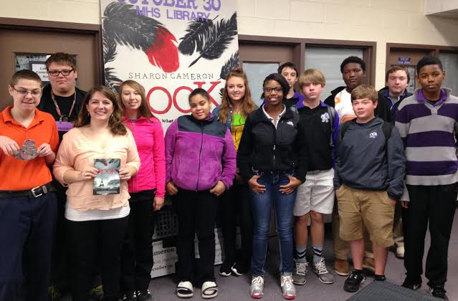

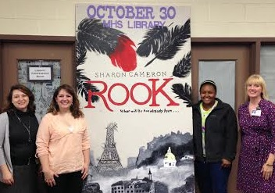
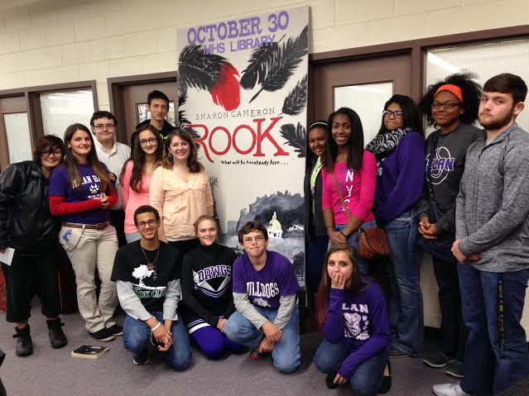
Circulation Statistics
510
Total books and other materials checked out of the library during October.
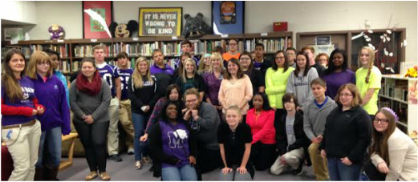

Student Visits in the Library
2,838
Total students in the library during the month of October.
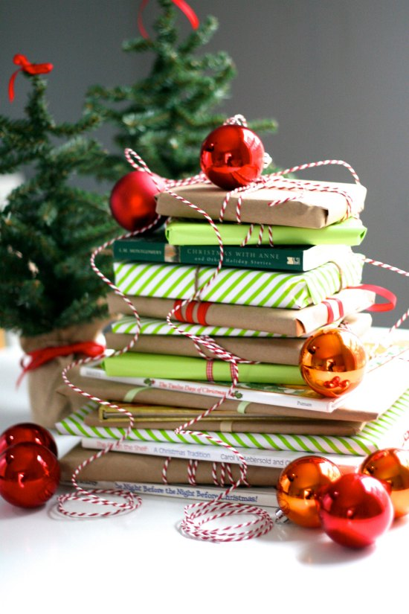
Please join us for our Book Fair, Nov. 30-Dec. 4th! MHS hosts a community fair with books for ALL AGES. Support the library and get free gift wrapping for purchases over $50. Visitors welcome!

