Milan High School Library September 2014
Carla Freeman, Librarian Khristy Stafford, Library Assistant

Back to School and to the Milan High School Library…
Beginning my 6th year as the Milan High School Librarian, I am once again excited to welcome back students as we start the 2014-2015 school year. This year I hope to accomplish big things through collection development, adding technology, and bringing in grant money to buy more books. However, the thing that keeps me loving my job is simply the opportunity to have relationships with our wonderful students. If I can encourage each young person that comes through the library to be their best and to know they are cared about, then I will count it a successful year.
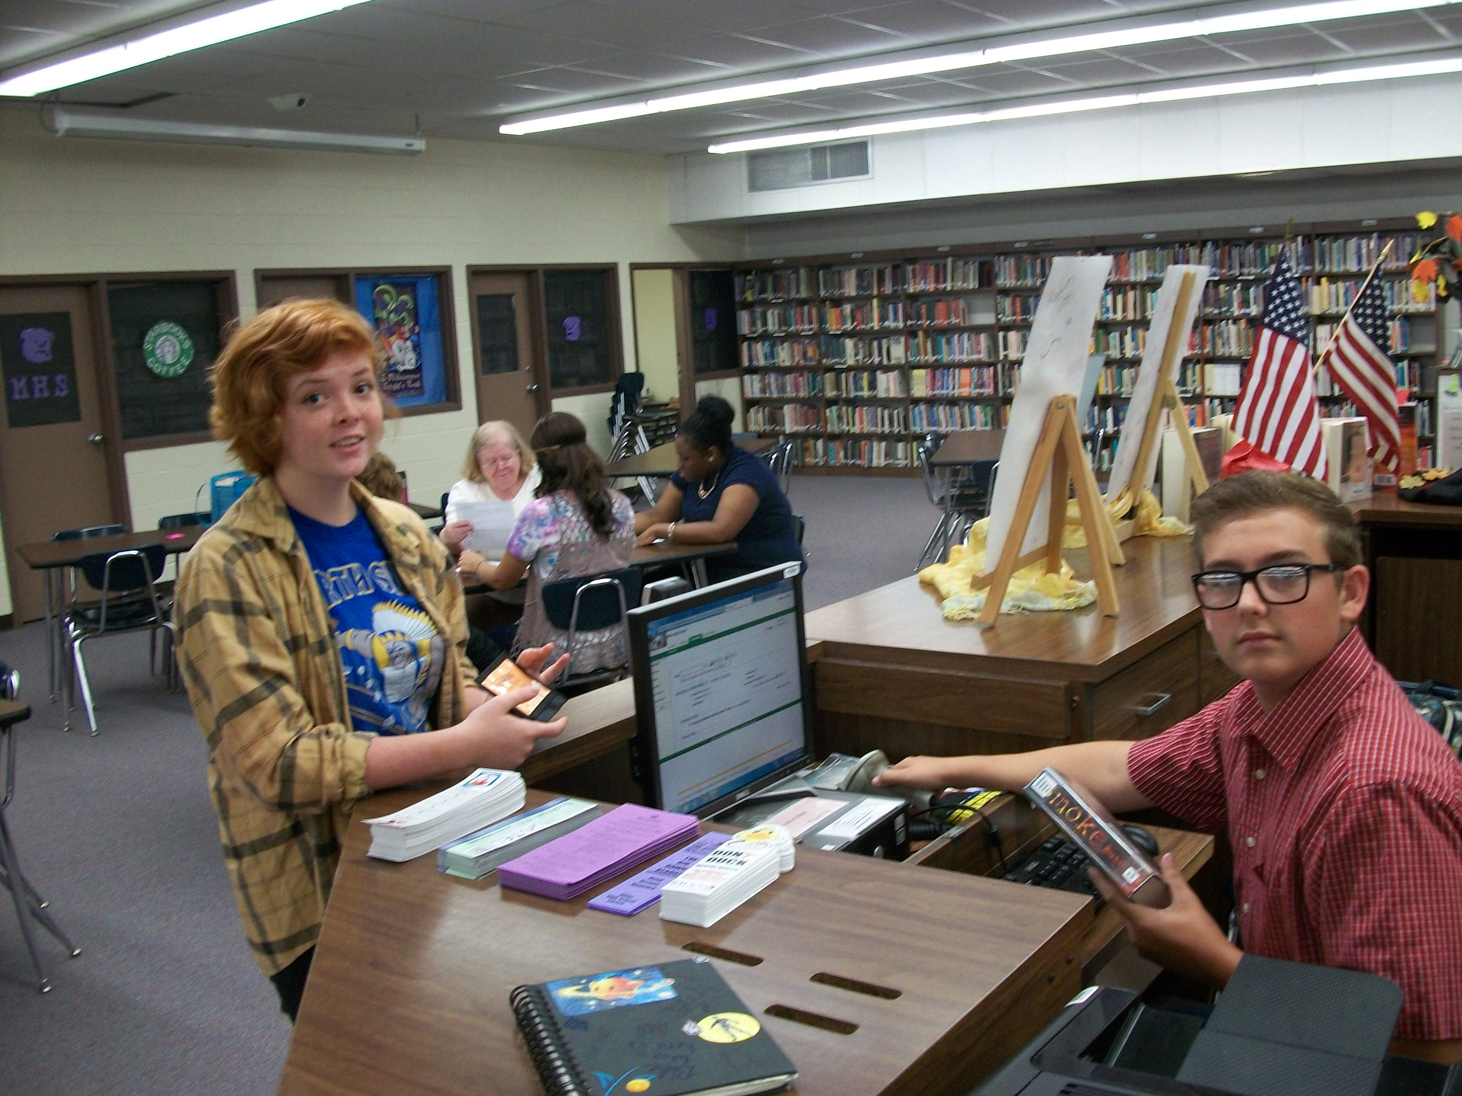

Circulation Statistics

623
Total books and other materials checked out of the library during August

Library Happenings in August

- 5 classes of freshmen were welcomed in the library during freshmen orientation
- Book Club meets with 32 members! We continue to grow every year and expand the culture of readers.
- 18 new students make up the Library Student Staff (see Noah Shackelford above)
- The Milan Mirror Exchange is now on sale every week in the library for $1. The Jackson Sun newspaper is now available in the library and online for free.

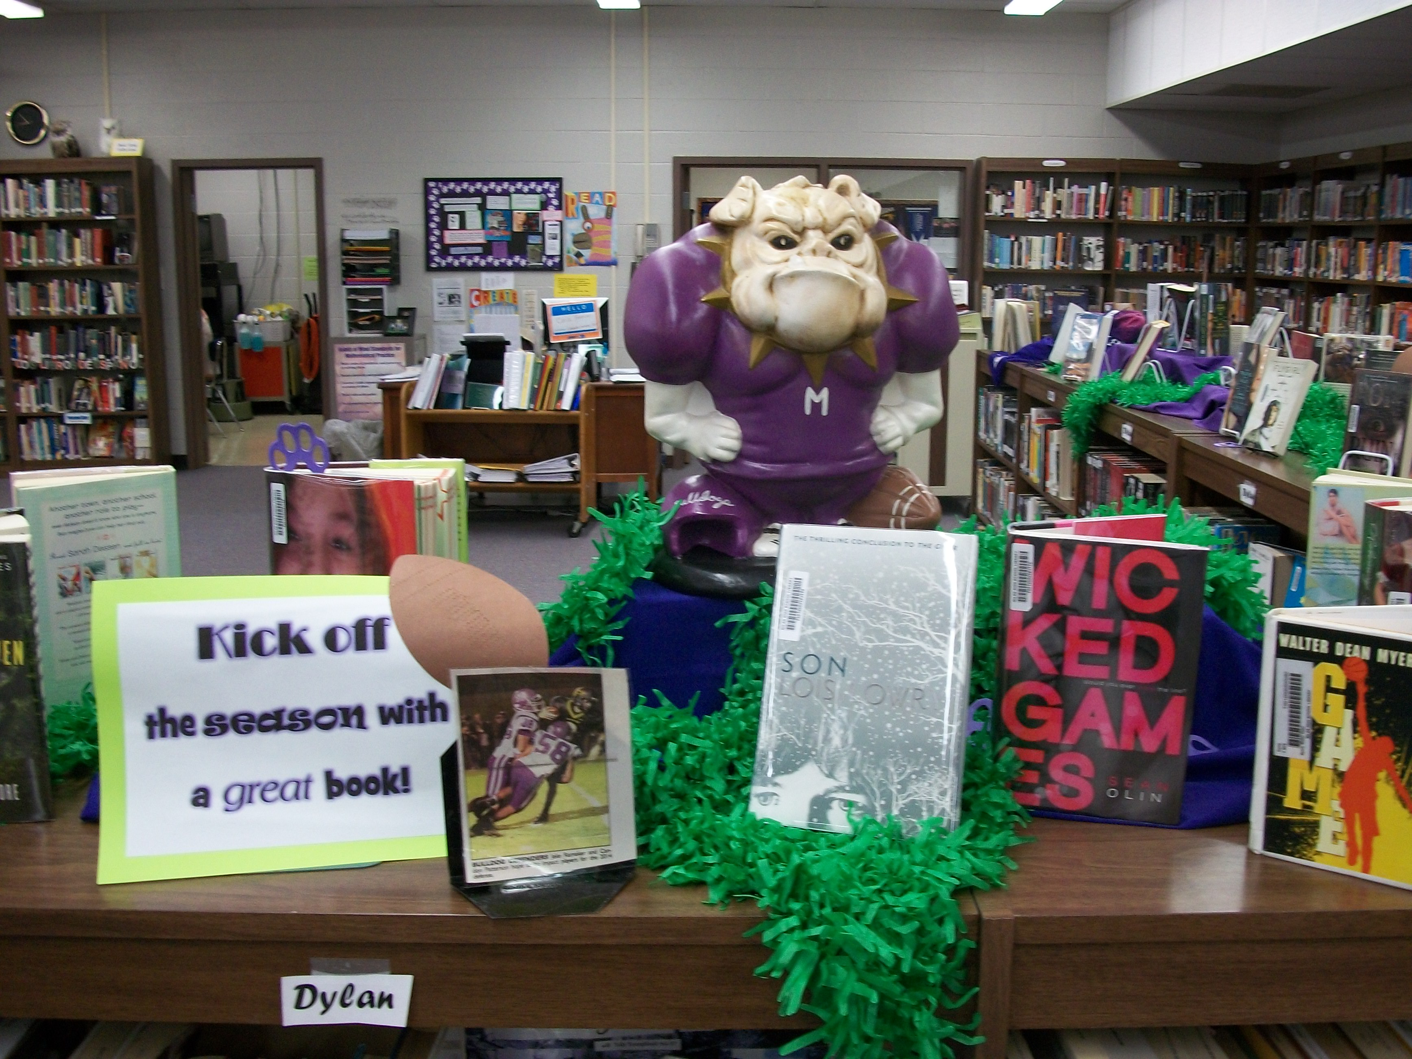
Festival Football Displays encourage students to “Kick off the season with a great book”. Pictures of the team, cheerleaders and the band are featured around the shelves.

Student Visits in the Library

3,337
Total students in the library during the month of August!

Join us in the MHS Library on Wednesday, September 10 for Literary Lunch featuring Author Courtney Stevens, sponsored by MEGA. Call 686-0841 for more details!

