“Fostering a love of reading and learning among the student body…”

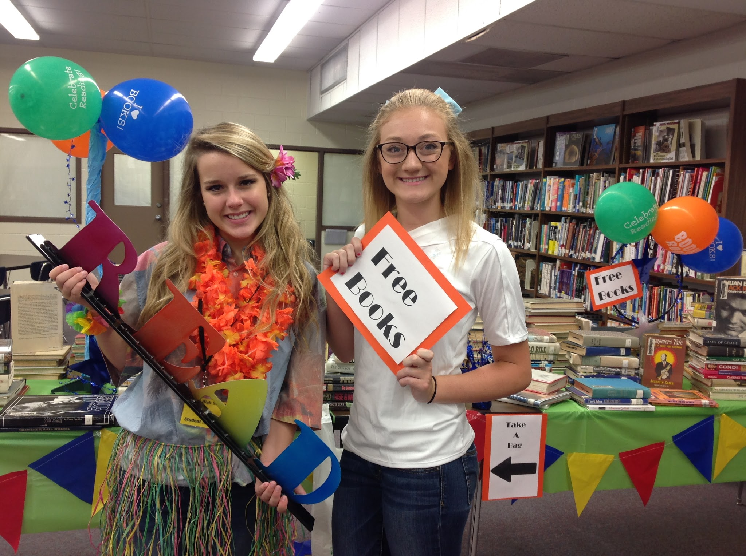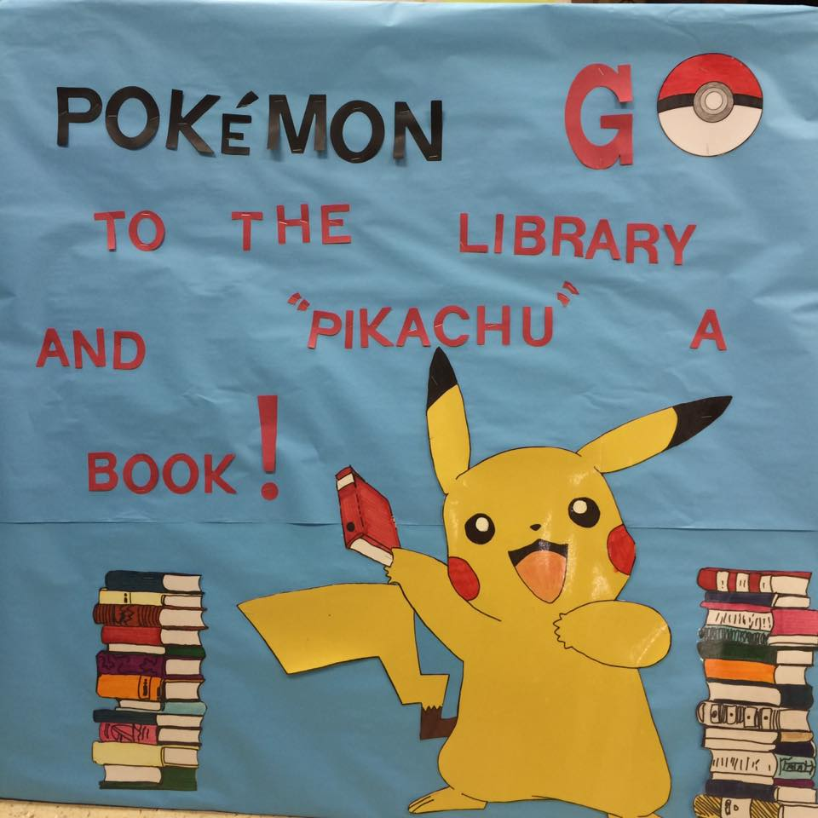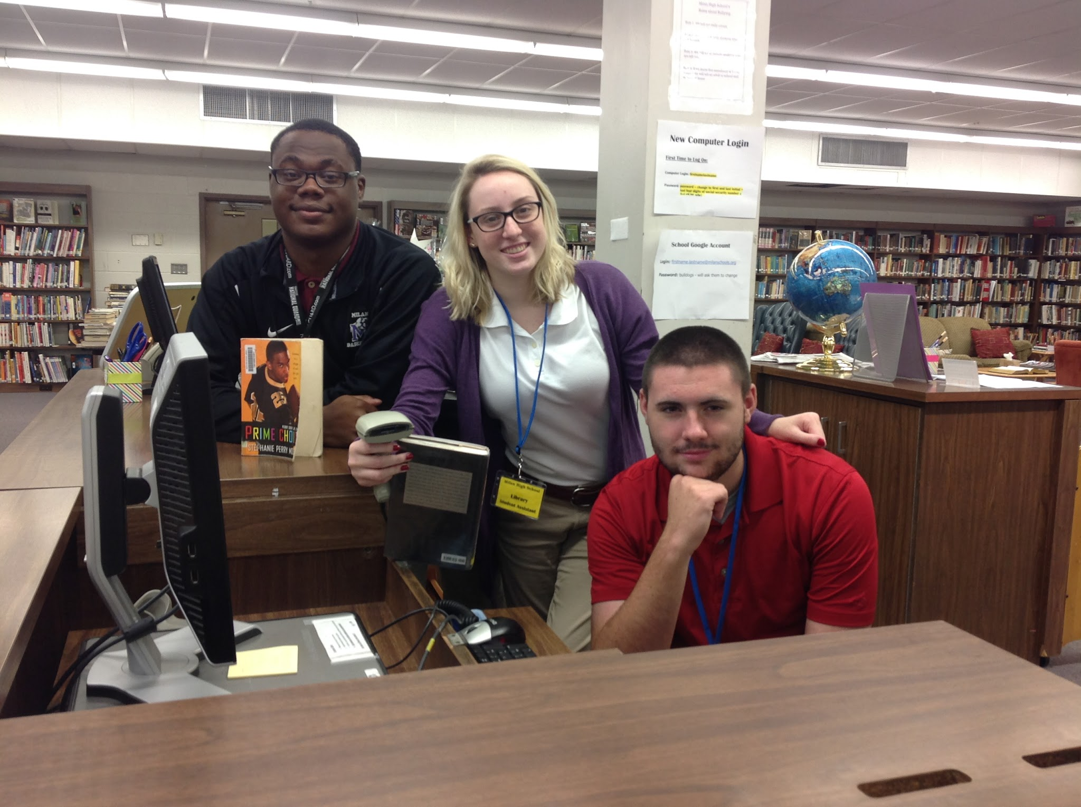
Free books! Pokemon What? New library students
We continue to weed old, Students help market 24 new students are bringing
out-dated inventory to the MHS Library with new marketing ideas, book
make room to add and displays like this bulletin promotions, and top-notch
showcase great books. board. Visit our library customer service to the library.
Students get the chance for new books, displays Student input and creativity are
to take home discards. & bookmarks! what make our library the best!

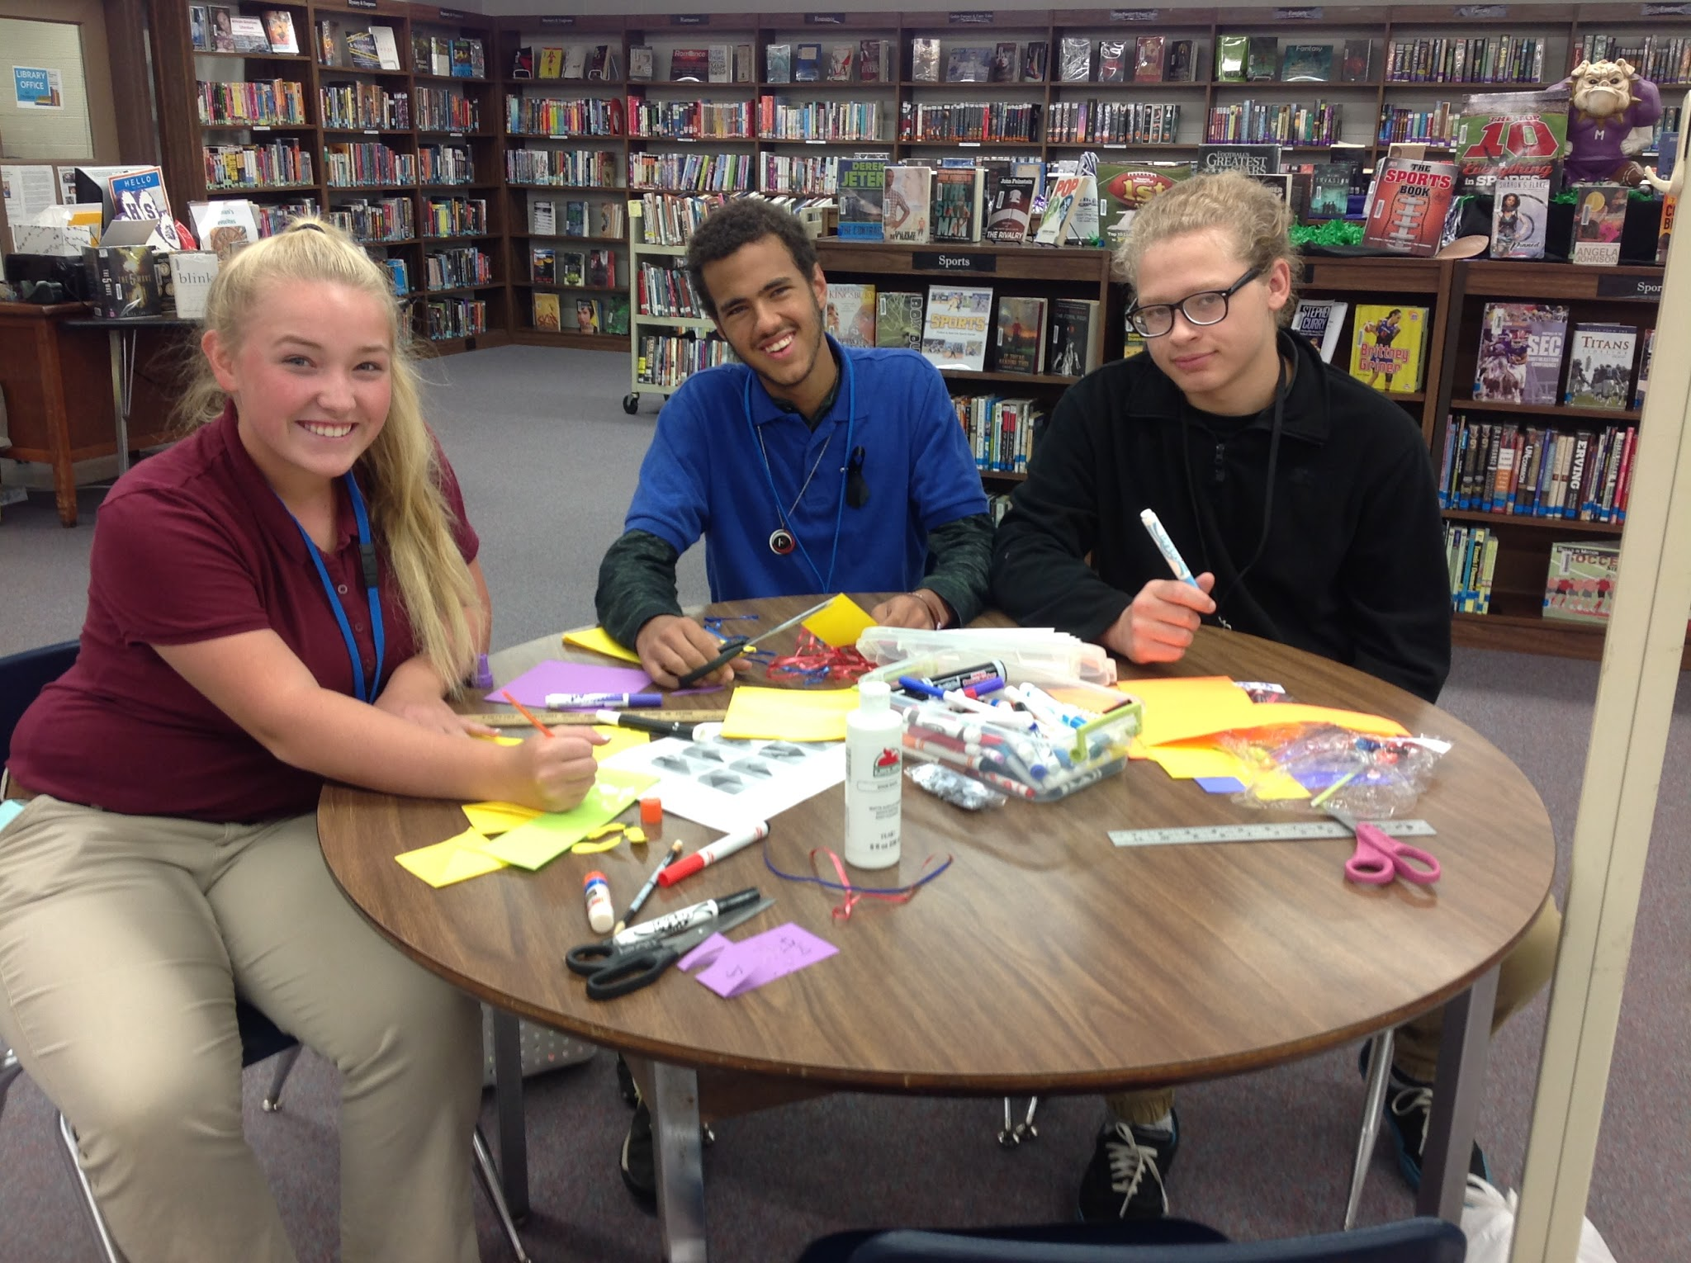
_____________________________________

Circulation stats:

636 2,018
Checkouts Student
For august Visits for AUgust

